# 3. Git-HOL

I learned the following in this hands-on lab:

- Explain branching and merging

- Create a branch request in GitLab

- Create a merge request in GitLab

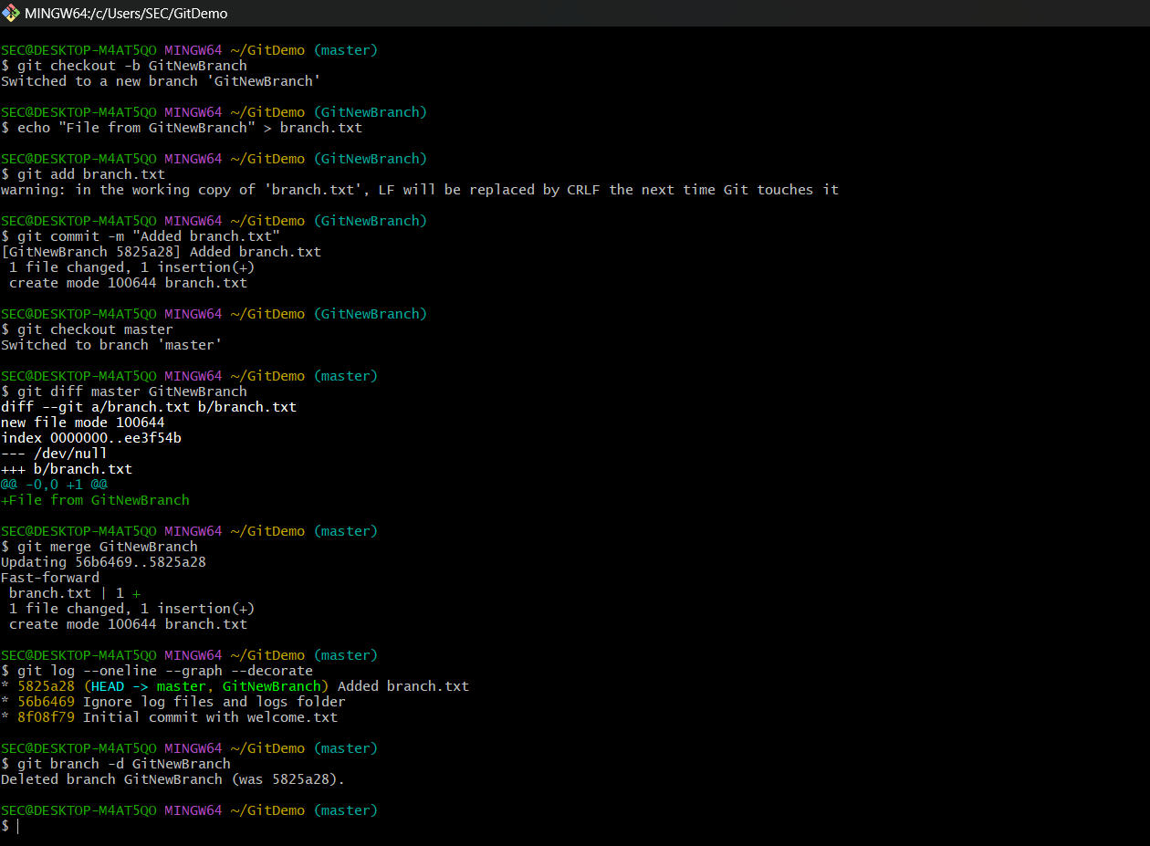

Summary of what I did:

Created a new branch 'GitNewBranch', added a file and committed changes, switched back to master, viewed differences, merged the branch into master, and deleted the branch.